Project 1 Report
CS7646
Author: Saad Rasool
srasool7@gatech.edu
1 In Experiment 1, based on the experiment results calculate and provide the estimated probability of winning $80 within 1000 sequential bets. Thoroughly explain your reasoning for answer using the experiment output. Your explanation should Not be based on estimates from visually inspecting your plots, but from analyzing any output from your simulation
From our simulated results, it was demonstrated that for 10 or 1000 episodes with 1000 sequential bets, the winnings always reached 80$ in less than 300 bets. This shows that probability of winning 80$ within 1000 sequential bets is 100%. This makes sense as every time we win we are adding 1$ to the winnings and when we do lose the bet, we are doubling are bet. Due to the infinite bank roll we can away come back to 80$ as we are betting significant money.
2 In Experiment 1, What is the estimated expected value of winnings after 1000 sequential bets, Thoroughly explain your reasoning for the answer
Estimated expected value of winnings is, so every time we win we add 1$ to our total wining, probability of wining as mentioned above is 0.474 (18/38), so every bet we can win 1 * 0.474 = 0.474. So for 1000 sequential bets our expected winnings would be 0.474*1000 = 474$. In our experiment we max our winnings to 80$ as an upper limit. If we didn't had an upper limit, the plots would show stabilization at 474$ instead.
3 In Experiment 1, do the upper standard deviation line ( mean + stdev) and lover standard line (mean – stdev) reach a maximum (or minimum) value and then stabilize ? Do the standard deviation lines converge as the number of sequential bets increases ? Thoroughly explain why it does or does not.
As shown in figure 2, which is based on our martingale experiment of 1000 episodes with 1000 sequential bets, and taking the mean and standard deviation of each spin. In the plot as demonstrated in the attachment section of this report. We are plotting the mean, mean +- stdev and standard deviation it self. We can see that the the mean, mean + stdev and – stdev do converge when the cap is reached, the main reason behind this is as in our experiment we are carrying forward 80$ winnings when reached. The standard dev line represents the variance in each spin and as there was no lower limit hence the spikes and when the 80$ limit is reached the standard dev is 0, which is around 220 mark. The mean + std and mean - std do not converge until the cap is reached.
4 In Experiment 2, based on the experiment results calculate and provide the estimated probability of winning $80 within 1000 sequential bets. Thoroughly explain your reasoning for the answer using the experiment output. Your explanation should not be based on estimated from visually inspecting your plots, but from analyzing any output from your simulation
In our experiment with having a lower limit on losses of 256$, out of 1000 episodes with 1000 sequential bets. 639/1000 reached 80$ and 361/1000 reached -256$, therefore the winning probability 639/1000 = 0.639 (63.9%) and losing probability =0.361 (36.1%)
5 In Experiment 2, what is the estimated expected value of winning after 1000 sequential bets? Thoroughly explain your response for the answer
From our experiment 2, we found out that our winning probability is 639/1000 = 63.9% and losing probability 36.1 %, based on these results our expected value of wining would be 0.639($80) +0.361(-256) = -41.3$, over the 1000 episode , with 1000 sequential bets.

6 In Experiment 2, do the upper standard deviation line (mean + sdev) and lower standard deviation line (mean -stdev) reach a maximum (or minimum) value and then stabilize ? Do the standard deviation lines converge as the number of sequential bets increase ? Thoroughly explain your response for the answer
From figure 4 as attached in the plot attachments, we can see that the mean + stdev and Mean -stdev do stabilize after reaching a minimum point, reason behind that is as we have a lower and upper bound to the experiment and we are carrying the value forward hence we would see the same thing on the upper bound. We can also see from the plot that the mean (expected value) also stabilizes around 200 bet mark. The standard deviation line do not and will not converge as the number of sequential bets increase, either they will stabilize around the upper limit (80$) or the lower limit (-256).

7 What are some of the benefits of using expected values when conducting experiments instead of simply using the result of one specific random episode ?
The main reason of using an expected value instead of the random episode is more data the better, basing your answer on one random episode might not give you the most realistic outcome. Where looking at the expected value provides an individual with a more realistic outcome. For example in one episode are wining could have reached 80$ in 800 bets and in the other 230 bets, taking the mean gives us a better understanding, and if we repeat this for multiple times we even get a better understanding.
- Plots Attachments:
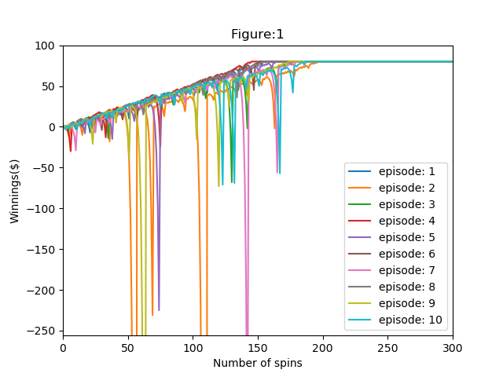
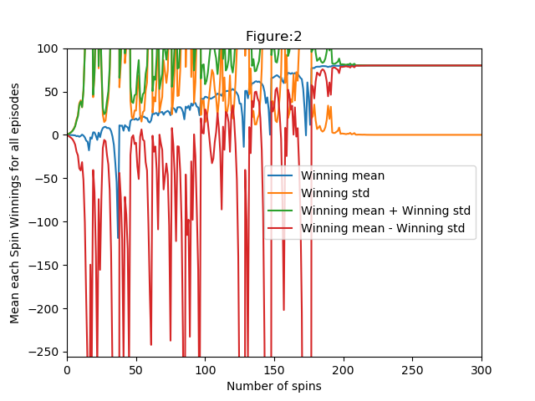
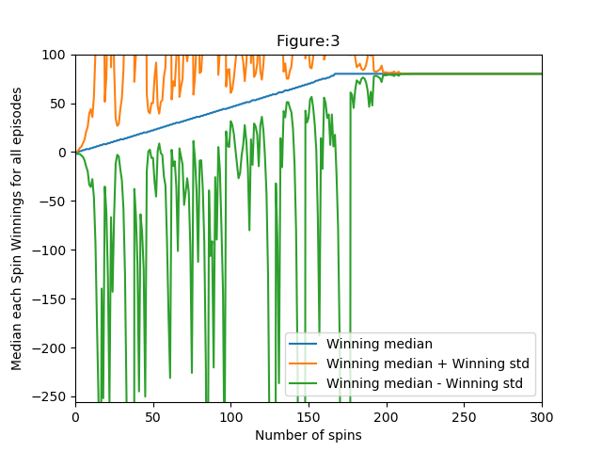
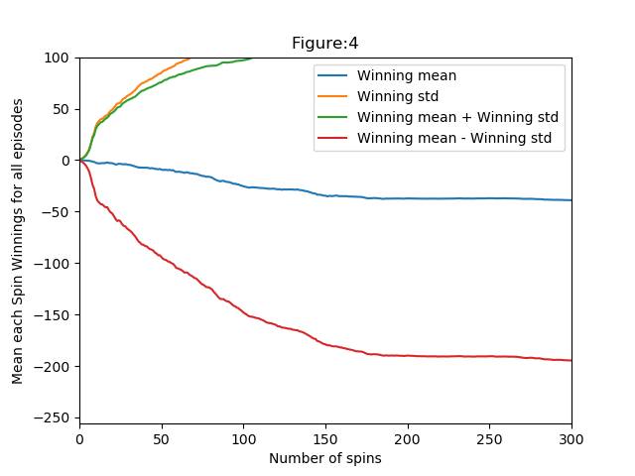
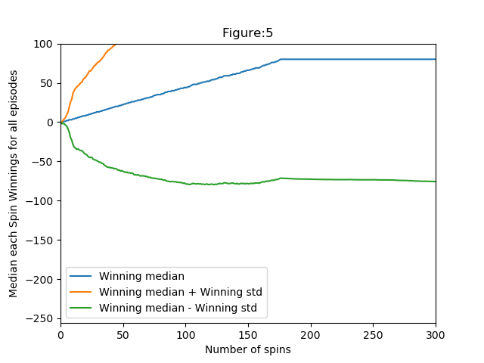
Reference lists
- https://numpy.org/doc/stable/user/basics.creation.html
- https://en.wikipedia.org/wiki/Expected_value
- An Introduction to Statistical Learning (Chapter 2)

